# CS 340 README Template

About the Project/Project Title

*This project is the implementation of a dashboard with widgets and a data table to search through a database of animals. The widgets included are a map to show details about the animal, and a pie chart to show information about all animals currently shown in the data table.*

## Motivation

*This project exists and was completed for the purpose of a school assignment.*

## Getting Started

*Create a python file that implements CRUD functions*

*In the given ipynb file, import the aforementioned python file*

*Hardcode database details such as “username”, “password”, “PASS”, “HOST”, “DB”, and “PORT”*

*Define the rescue categories*

*Connect to the database*

*Implement the custom logo, ensure the image file is in the same folder as the project*

*Create a dropdown menu that uses the defined rescue categories*

*Implement Update functions*

## Installation

*MongoDB*

*Python*

## Usage

*Use this space to show useful examples of how your project works and how it can be used. Be sure to include examples of your code, tests, and screenshots.*

### Code Example

*The project allows a user to filter a database by three different rescue animal types (as in, animals that would be good for the job of rescue). The user may also view a map of where animals are and a pie chart to show the proportions of breeds in each filtered category*

*\*Note: when unfiltered, the pie chart may be difficult to use due to the quantity of breeds.*

*Defined Rescue Categories*

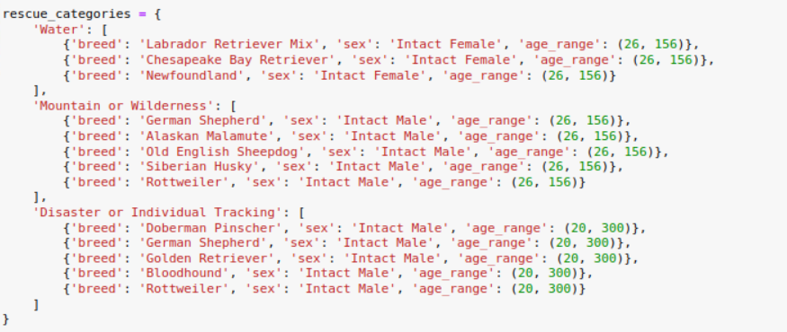

*Dropdown menu*

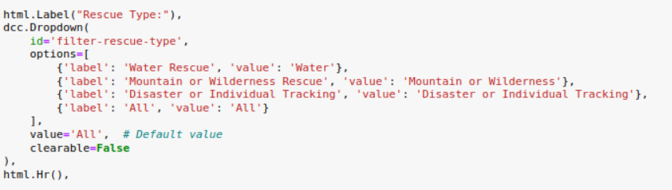

*Update dashboards (uses rescue categories)*

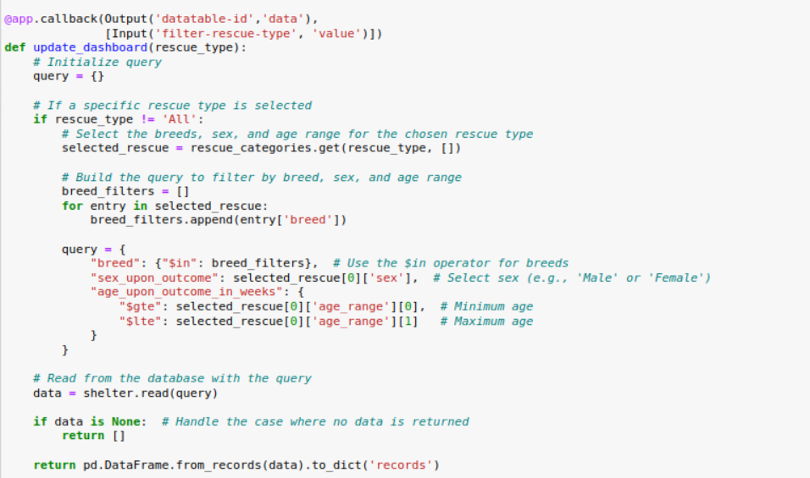

*Update graphs*

Update styles

Portion of Update map

### Tests

*The primary tests I did were by testing each part of code while implementing it, for example, I would implement one of the “FIX ME”s and then test to make sure my implementation worked.*

### Screenshots

## Contact

Bee Best

https://github.com/Best-Bee

beebest101010@gmail.com